|  |
| --- |
| REPORT |
| 4th Homework |

|  |  |
| --- | --- |
| Subject | Computational Microelectronics |
| Professor | 홍 성 민 |
| Name | 조 성 훈 |
| Student Number | 20162071 |
| Due Date | 2018/10/1 - 8AM |



1. Write your own code for the double-gate structure
   1. This code is for question 1st, 2nd, 3rd, and 4th

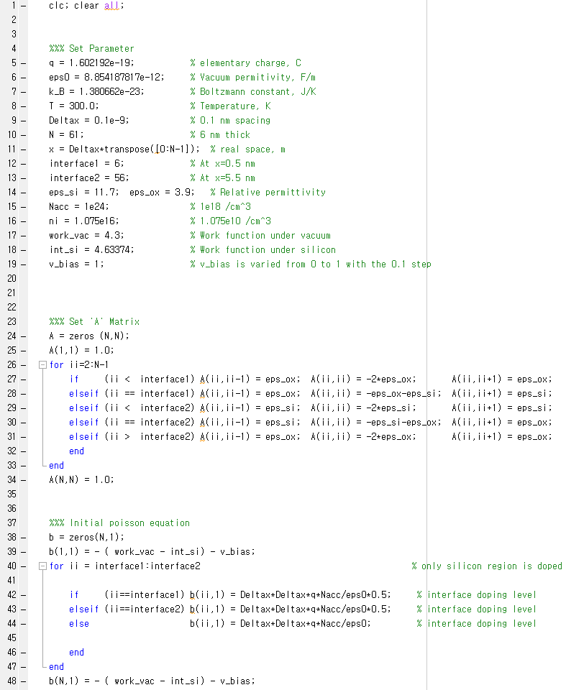

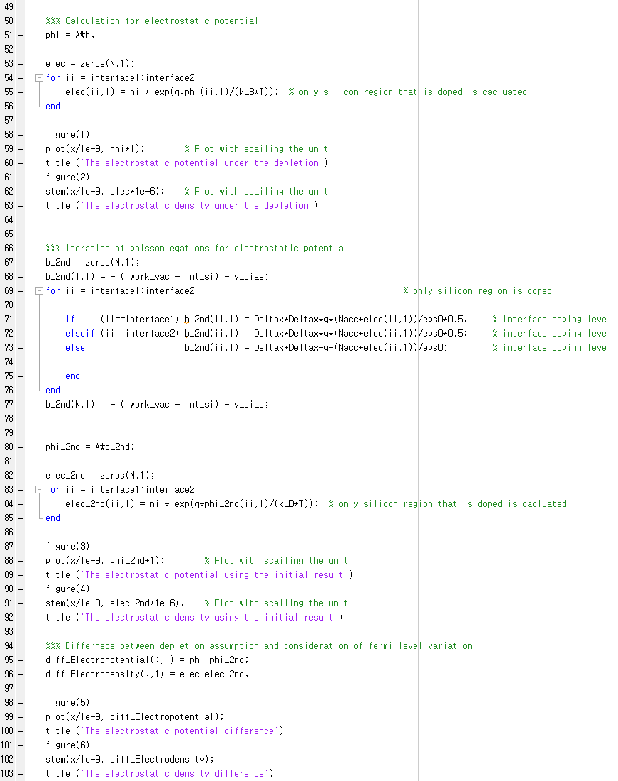

* 1. This code is for question 5th

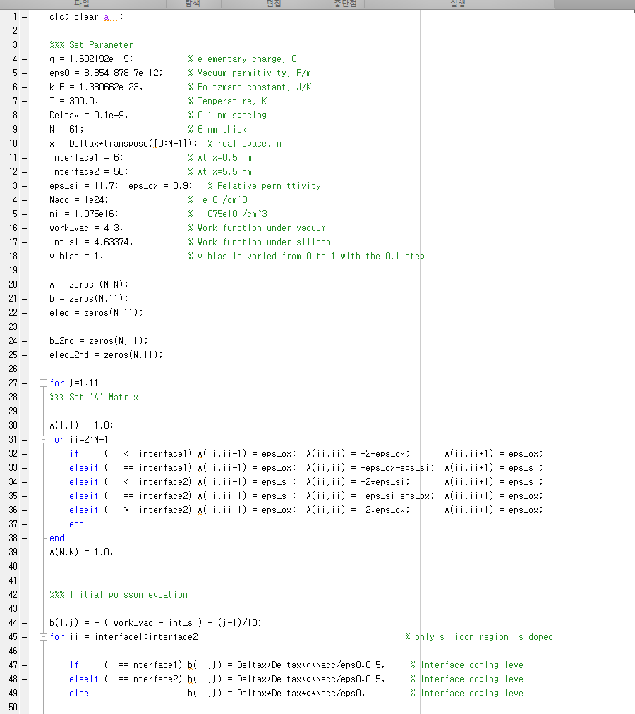

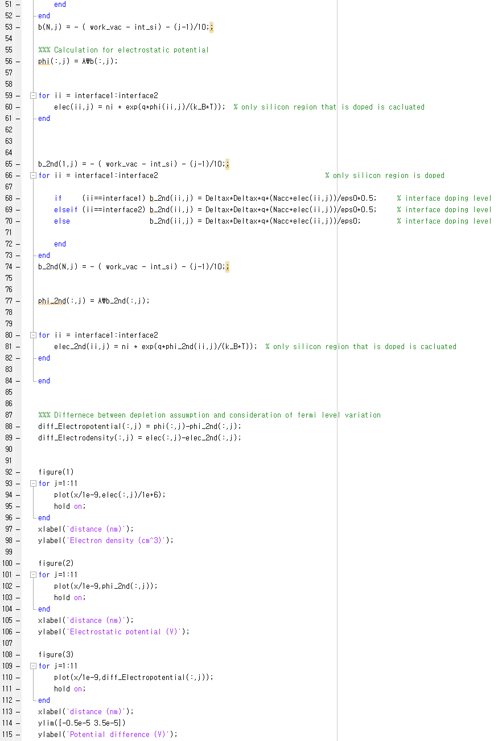

1. The electrostatic potential is obtained under the depletion approximation. (The initial potential)



* 1. The electrostatic potential is divided by three region
     1. The first region is ‘x_SiO2 = [0, 5nm]’. At this point because of the free-charge space, the slop is linear.
     2. The second region is ‘x_Si = [5, 55nm]’. At this point because of the existence of the dopant, the slop is parabolic.
     3. The first region is ‘x_SiO­2 = [55, 60nm]’. At this point because of the free-charge space, the slop is linear.

1. The electron density is calculated by assuming ni*exp(q*phi/kB/T)



* 1. Using the interface doping charge equation, we can find the electrostatic density
  2. Because of the free charge space of the SiO2, the ranges of ‘[0, 5 nm]’, ‘[55 nm, 60 nm]’ have zero electron density.

1. Then, using the electron density, re-calculate the potential. (The updated potential)

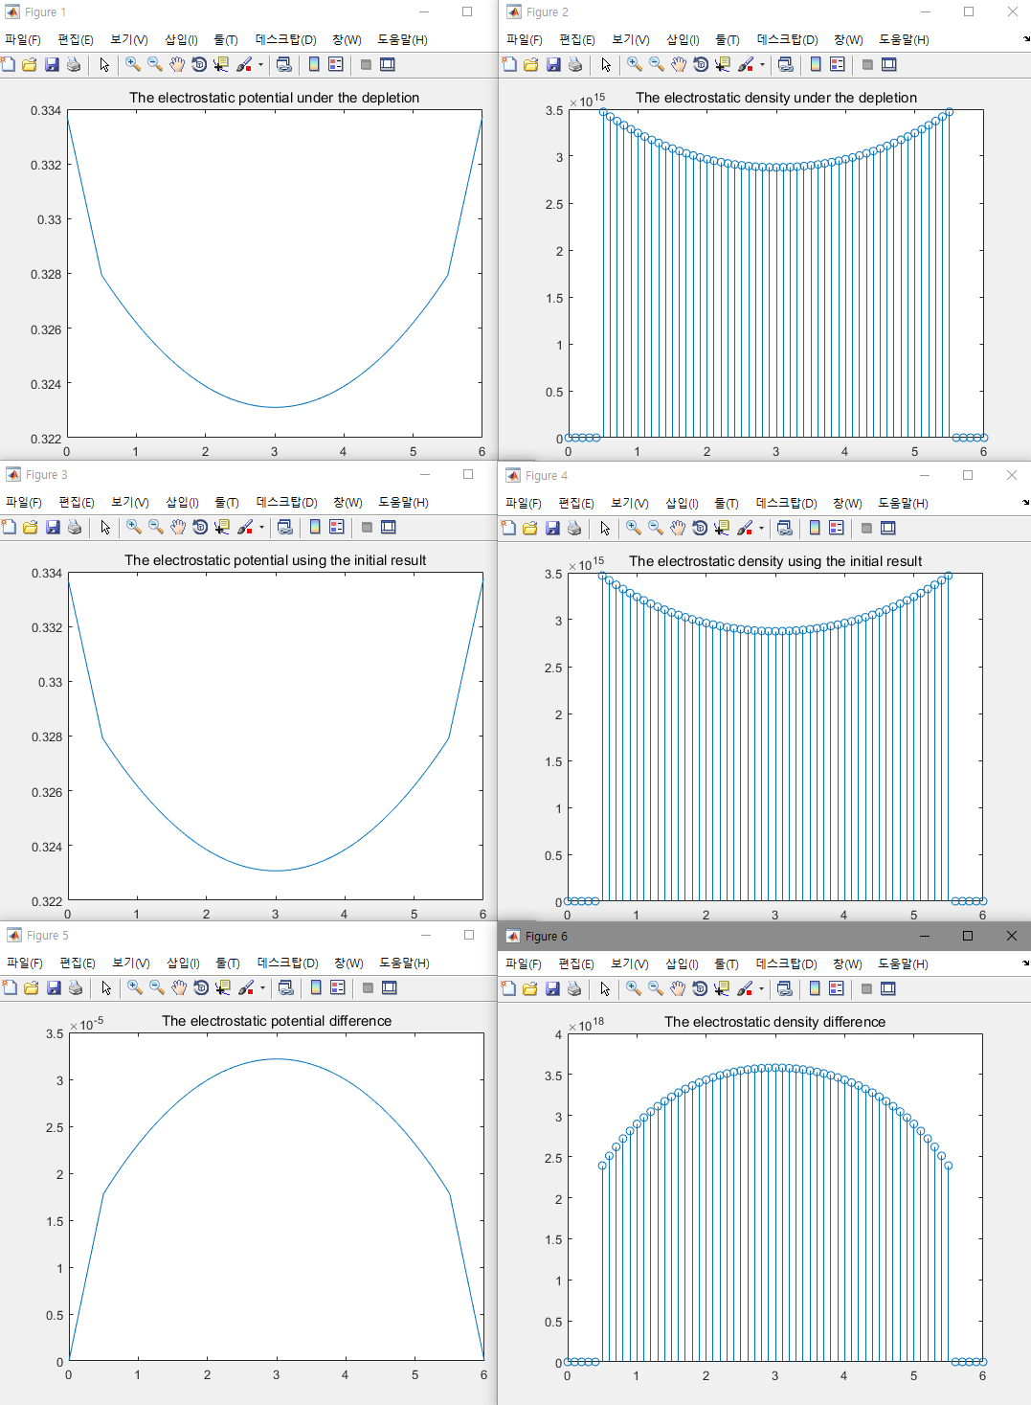

* 1. The difference electrostatic potential and electron density exist
  2. This difference is introduced by electron density that it was assumed by depletion in the Si region (range from 5 nm to 55nm)
  3. This charge which make potential difference can be accurately calculated by this iteration process

1. Check their difference for several gate voltages from 0 V to 1V. (The voltage step is 0.1 V. 11points in total)

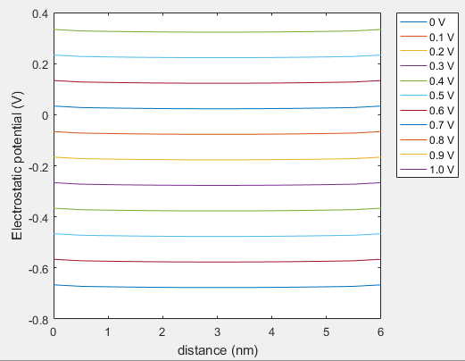

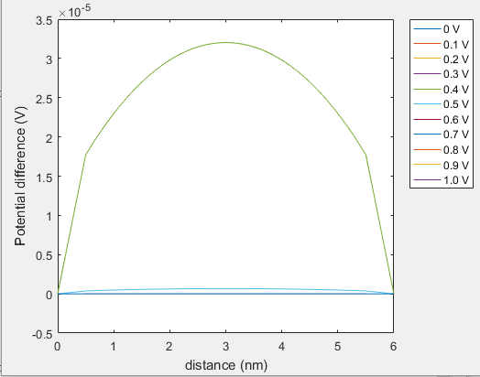 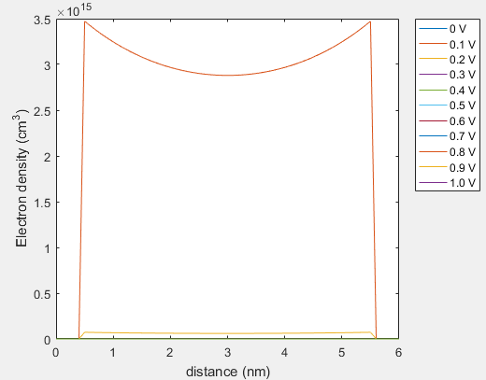

* 1. When the gate voltage is varied from 0V to 1V, the difference is drastically reduced
     1. The electron density is function of energy of conduction band
     2. This relation is inverse proportional and exponentially decrease with EC
     3. When the larger gate bias is applied, the energy of conduction band is greater than no bias condition
     4. So, the electron density in the Si region is drastically reduced